NAME: MUJTABA SHAHID FAIZI

CLASS: BSCS-5A

REG NO# 131818

LAB 10

WEB ENGINEERING

TASK 1:

<html ng-app="nameApp">

<head>

<meta charset="utf-8">

<title>AngularJS Lab Task-1 </title>

</head>

<body ng-controller="NameCtrl">

<ul>

<li ng-repeat="name in names">{{name}}</li>

</ul>

<form ng-submit="addName()">

<input type="text" ng-model="enteredName">

<input type="submit" value="add">

</form>

<script src="angular-1.3.14.js"></script>

<script>

var nameApp = angular.module('nameApp', []);

nameApp.controller('NameCtrl', function ($scope){

$scope.names = ['David', 'John', 'Paul', 'Mark', 'Christopher', 'Williams'];

$scope.addName = function() {

var a=false;

for(i=0;i<$scope.names.length;i++){

if ($scope.names[i]==$scope.enteredName){

alert($scope.names[i] + ' already exists!');

a=true;

break;}

}

if(a==false)

{

$scope.names.push($scope.enteredName);

}

};

});

</script>

</body>

</html>

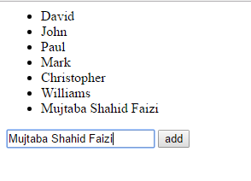

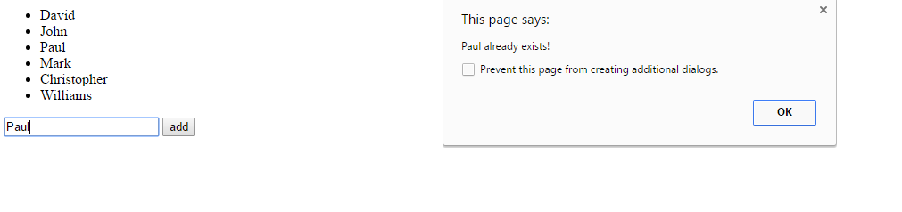

TASK 2:

<html>

<head>

<style>

</style>

</head>

<title>AngularJS Directives:: init, repeat</title>

<body>

<h1></h1>

<div ng-app="" ng-init="countries=[{Country_Name:'Arab World',Country_Code:'ARB',Year:'1960',Value:'93485943'},

{Country_Name:'Arab World',Country_Code:'ARB',Year:'1961',Value:'96058179'},

{Country_Name:'Arab World',Country_Code:'ARB',Year:'1962',Value:'98728995'},

{Country_Name:'Arab World',Country_Code:'ARB',Year:'1963',Value:'101496308'},

{Country_Name:'Arab World',Country_Code:'ARB',Year:'1964',Value:'104359772'},

{Country_Name:'Arab World',Country_Code:'ARB',Year:'1965',Value:'107318159'},

{Country_Name:'Arab World',Country_Code:'ARB',Year:'1966',Value:'110379639'},

{Country_Name:'Arab World',Country_Code:'ARB',Year:'1967',Value:'113543760'},

{Country_Name:'Arab World',Country_Code:'ARB',Year:'1968',Value:'116787194'},

{Country_Name:'Arab World',Country_Code:'ARB',Year:'1969',Value:'120078092'},

{Country_Name:'Arab World',Country_Code:'ARB',Year:'1970',Value:'123400916'},

{Country_Name:'Arab World',Country_Code:'ARB',Year:'1971',Value:'126726106'},

{Country_Name:'Arab World',Country_Code:'ARB',Year:'1972',Value:'130095625'},

{Country_Name:'Arab World',Country_Code:'ARB',Year:'1973',Value:'133592409'},

{Country_Name:'Arab World',Country_Code:'ARB',Year:'1974',Value:'137327448'},

{Country_Name:'Arab World',Country_Code:'ARB',Year:'1975',Value:'141376124'},

{Country_Name:'Arab World',Country_Code:'ARB',Year:'1976',Value:'145768518'},

{Country_Name:'Arab World',Country_Code:'ARB',Year:'1977',Value:'150474227'},

{Country_Name:'Arab World',Country_Code:'ARB',Year:'1978',Value:'155422735'},

{Country_Name:'Arab World',Country_Code:'ARB',Year:'1979',Value:'160508834'},

{Country_Name:'Arab World',Country_Code:'ARB',Year:'1980',Value:'165653287'},

{Country_Name:'Arab World',Country_Code:'ARB',Year:'1981',Value:'170835489'},

{Country_Name:'Arab World',Country_Code:'ARB',Year:'1982',Value:'176068130'},

{Country_Name:'Arab World',Country_Code:'ARB',Year:'1983',Value:'181346070'},

{Country_Name:'Arab World',Country_Code:'ARB',Year:'1984',Value:'186631963'},

{Country_Name:'Arab World',Country_Code:'ARB',Year:'1985',Value:'192047001'},

{Country_Name:'Arab World',Country_Code:'ARB',Year:'1986',Value:'197522280'},

{Country_Name:'Arab World',Country_Code:'ARB',Year:'1987',Value:'202985205'},

{Country_Name:'Arab World',Country_Code:'ARB',Year:'1988',Value:'208460437'},

{Country_Name:'Arab World',Country_Code:'ARB',Year:'1989',Value:'213911862'},

{Country_Name:'Arab World',Country_Code:'ARB',Year:'1990',Value:'221488293'},

{Country_Name:'Arab World',Country_Code:'ARB',Year:'1991',Value:'227470711'},

{Country_Name:'Arab World',Country_Code:'ARB',Year:'1992',Value:'231443007'},

{Country_Name:'Arab World',Country_Code:'ARB',Year:'1993',Value:'237333236'},

{Country_Name:'Arab World',Country_Code:'ARB',Year:'1994',Value:'243241854'},

{Country_Name:'Arab World',Country_Code:'ARB',Year:'1995',Value:'250504422'},

{Country_Name:'Arab World',Country_Code:'ARB',Year:'1996',Value:'255932514'},

{Country_Name:'Arab World',Country_Code:'ARB',Year:'1997',Value:'261245142'},

{Country_Name:'Arab World',Country_Code:'ARB',Year:'1998',Value:'266504558'},

{Country_Name:'Arab World',Country_Code:'ARB',Year:'1999',Value:'271911978'},

{Country_Name:'Arab World',Country_Code:'ARB',Year:'2000',Value:'277550423'},

{Country_Name:'Arab World',Country_Code:'ARB',Year:'2001',Value:'283470089'},

{Country_Name:'Arab World',Country_Code:'ARB',Year:'2002',Value:'289647968'},

{Country_Name:'Arab World',Country_Code:'ARB',Year:'2003',Value:'296095945'},

{Country_Name:'Arab World',Country_Code:'ARB',Year:'2004',Value:'302824676'},

{Country_Name:'Arab World',Country_Code:'ARB',Year:'2005',Value:'309824383'},

{Country_Name:'Arab World',Country_Code:'ARB',Year:'2006',Value:'317125787'},

{Country_Name:'Arab World',Country_Code:'ARB',Year:'2007',Value:'324693498'},

{Country_Name:'Arab World',Country_Code:'ARB',Year:'2008',Value:'332424892'},

{Country_Name:'Arab World',Country_Code:'ARB',Year:'2009',Value:'340149038'}]">

<p>Enter your Name: <input type="text" ng-model="countriesList"></p>

<p>Hello <span ng-bind="countriesList"></span>!</p>

<p>List of Countries with locale:</p><table>

<table border="1px" align="center">

<tr><th>Country Name</th><th>Code</th><th>Year</th><th>Value</th></tr>

<tr ng-repeat="country in countries"><td>{{country.Country_Name}}</td><td>{{country.Country_Code}}</td><td>{{country.Year}}</td><td>{{country.Value}}</td></tr>

</table>

</div>

<script src="angular-1.3.14.js"></script>

</body>

</html>

